Lab 5 Post-Lab, Chase Dustevich and Colby Wallace

1)
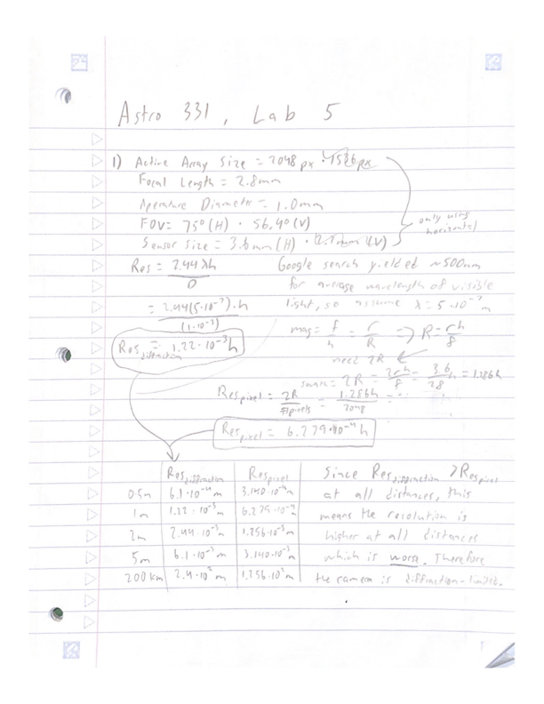
2)
Page Height=19.7cm
Actual Resolution determined by taking the page height divided by the (estimated) line times the ISO chart reference scaler listed at the top, as seen below:
0.5m: can see the 3.2 line, so 0.197/(3.2*100)=0.0006156 m
1m: can see the 2.2 line, so 0.197/(1.5*100)=0.001313 m
2m: can see the 3.8 line, so 0.197/(3.8*20)=0.002592 m
5m: can see the 1.5 line, so 0.197/(1.5*20)=0.006567 m
Distance | Theoretical Diffraction | Theoretical Pixel | Actual
0.5m | 6.1*10^-4 m | 3.140*10^-4m | 6.156*10^-4 m
1m | 1.22*10^-3 m | 6.279*10^-4 m | 1.313 *10^-3 m
2m | 2.44*10^-3 m | 1.256*10^-3 m | 2.592*10^-3 m
5m | 6.1*10^-3 m | 3.140*10^-3 m | 6.567*10^-3 m
200k | 2.4*10^2 m | 1.256*10^2 m | N/A

3)
1. One source of error between our actual results and theoretical results could like in human error on setting the focus of the camera. While we tried our best to get it focused, precise rotation of the camera lens was difficult, and it was likely not perfectly focused. We also realized that the minimum focus distance of the camera was 0.6m, while we were setting the focus at a distance of 0.5m so our chosen focus was likely not perfect, and this was noticed in our results. See Figures 1 & 2 at a distance of 0.5m, where the focus of the lens is imperfect.
2. Another source of error is in the fact that the camera outputted the pictures in .JPG format which uses compression to decrease the file size. In most cases this is good but could likely decrease the quality of the image for our viewing. This compression could slightly change colors and/or combine colors of nearby pixels which would decrease the quality and increase the resolution based on pixels.
3. A final source of error could be microscopic scratches or smudges on the lens which scatter or change how the light is entering the camera and could decrease the quality of the image and thus increase the resolution. While we tried to avoid this source of error by making sure the lens was clean and unobstructed, this is only possible to a certain extent and could bring another source of error between the theoretical and actual resolutions.
According to Google, the average city block is 100m*200m. Since the resolution of our camera at 200km is 244m, it would likely be very difficult to distinguish the city block as it is smaller than our resolution. The city block would likely blend into the background, although the color of the pixel might change to represent the city block environment compared to what is around it.

4)
Referencing Figures 6 & 7, slight distortion can be seen around the corners of the image. This is exemplified when looking for details in the corners, where they are less focused. Causes of this distortion can be found when examining the lens’s construction. The lens focuses the light onto a curved surface, while the sensor of the ArduCam is flat. This issue is not present in the center of the image, as that is where the lens focuses the light perfectly to the flat sensor. However, the edges of the sensor are a further distance away from the curved lens and thus they are not perfectly focused like the center. Because of this, the picture edges of camera and lens with this design are going to be slightly unfocused around the edges even if perfectly focused for the center, as show in our pictures. This changing of distance and angle the light arrives can also slightly affect the colors of the light, which at greater distances can slightly skew the image especially with the compression found in the .JPG pictures our camera outputs. This sources of error are small in our tests at a maximum of 5m but would likely present a far larger issue at distances such as 200km.

5)
Pick minimum resolution: 25m
For a 300m long and 75m wide carrier this equates to 12 pixels long and 3 pixels wide. 36 total pixels should be more than enough to discern the location of a carrier.
Find the aperature diameter:
Find the Resolution R
Double to find Swath Width = 51.2km
Find r as half the sensor width = 1.8mm
Find focal length f
Assume wavelength of 5x10^-7 for lambda/average light wavelength, camera pointed straight down, no atmospheric effects/losses/weather, no dusty/smudged camera.

Documentation Statement: Used the Lab 5 slideshow, class slideshows, class notes, and a calculator to answer all questions. Referenced Google for assumptions where required and noted. No other outside resources were used.

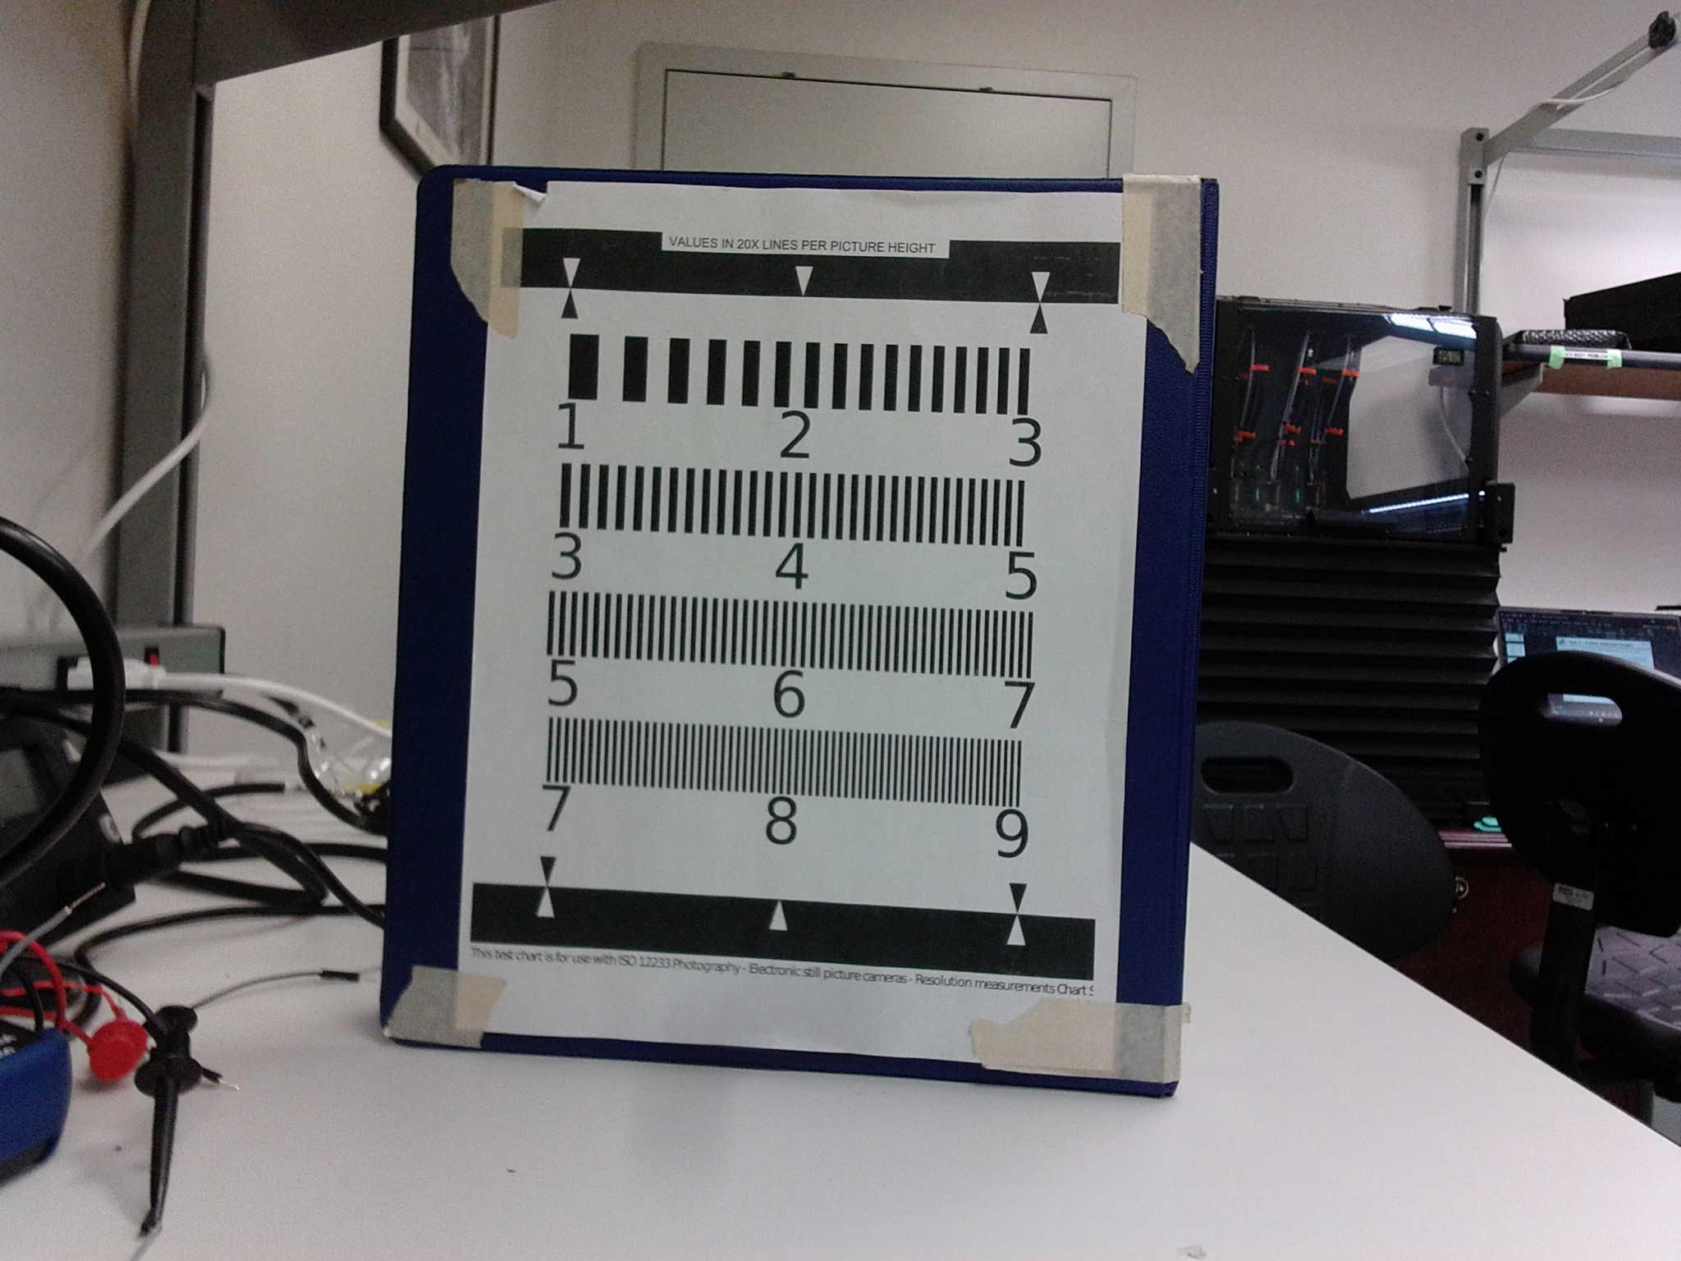
Figure 1: 0.5m distance, Side 1
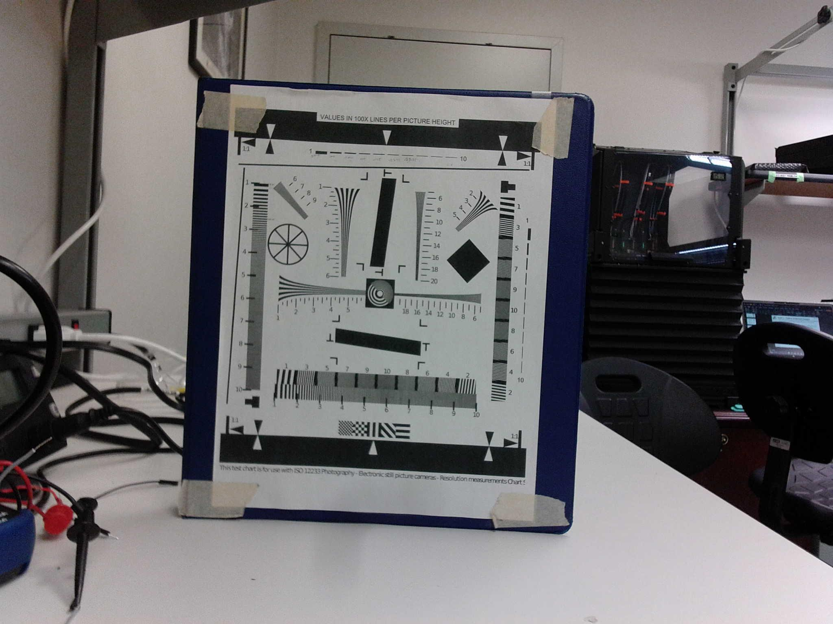
Figure 2: 0.5m distance, Side 2

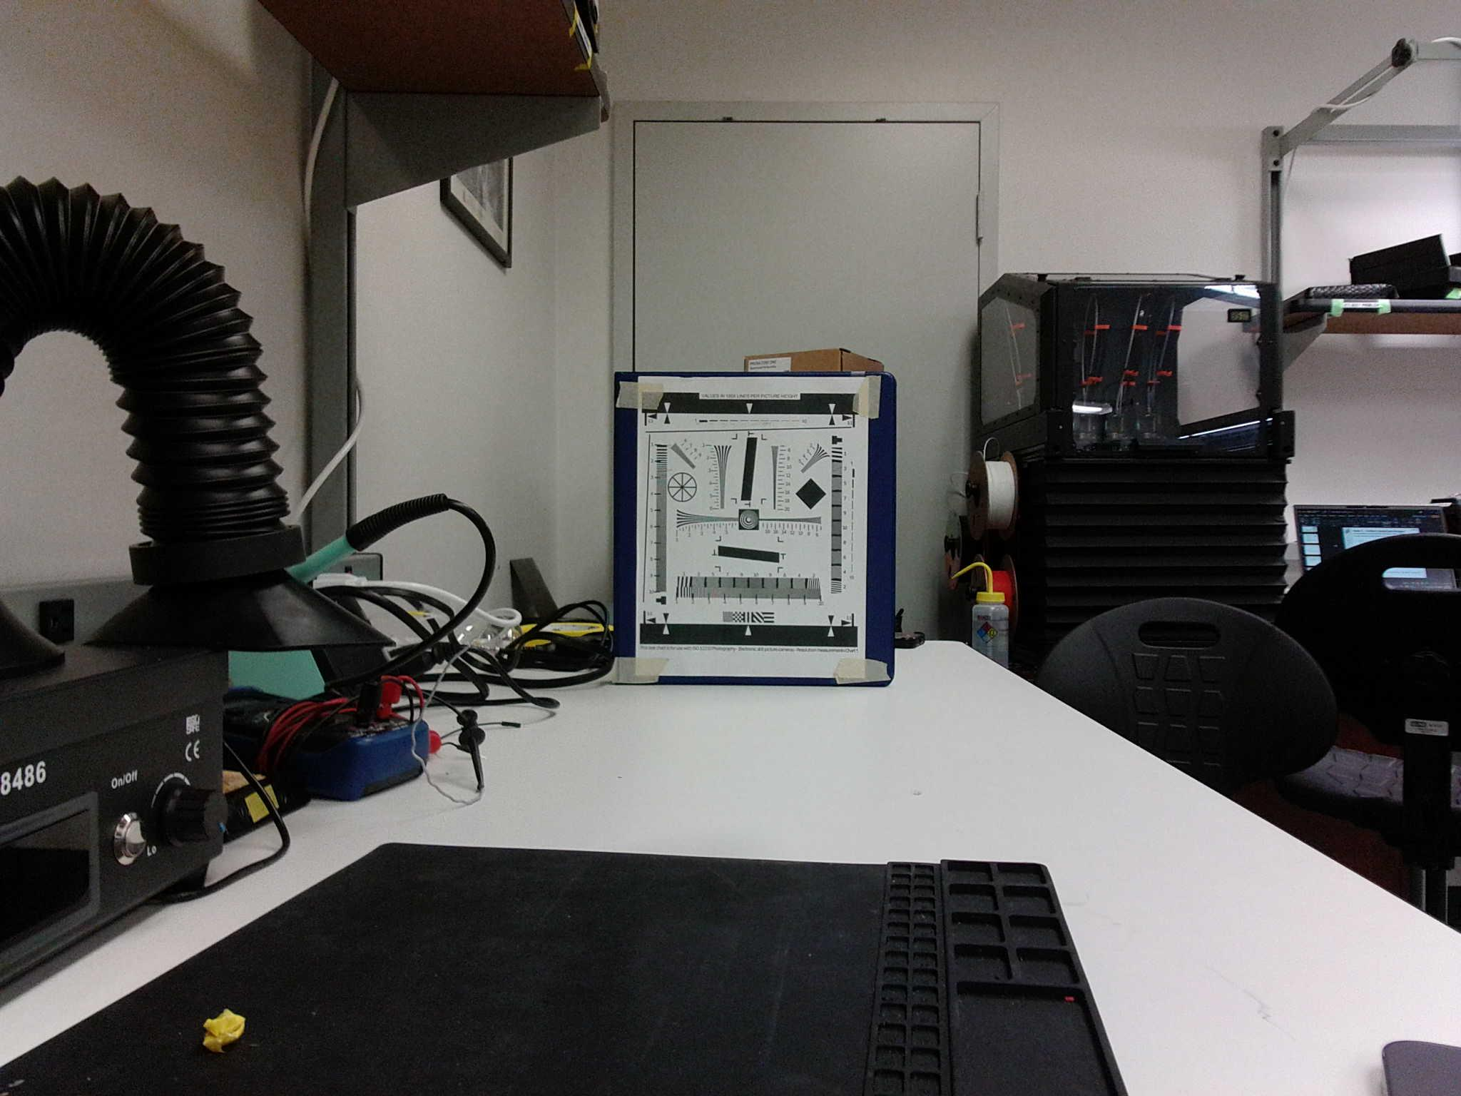
Figure 3: 1m distance, Side 2
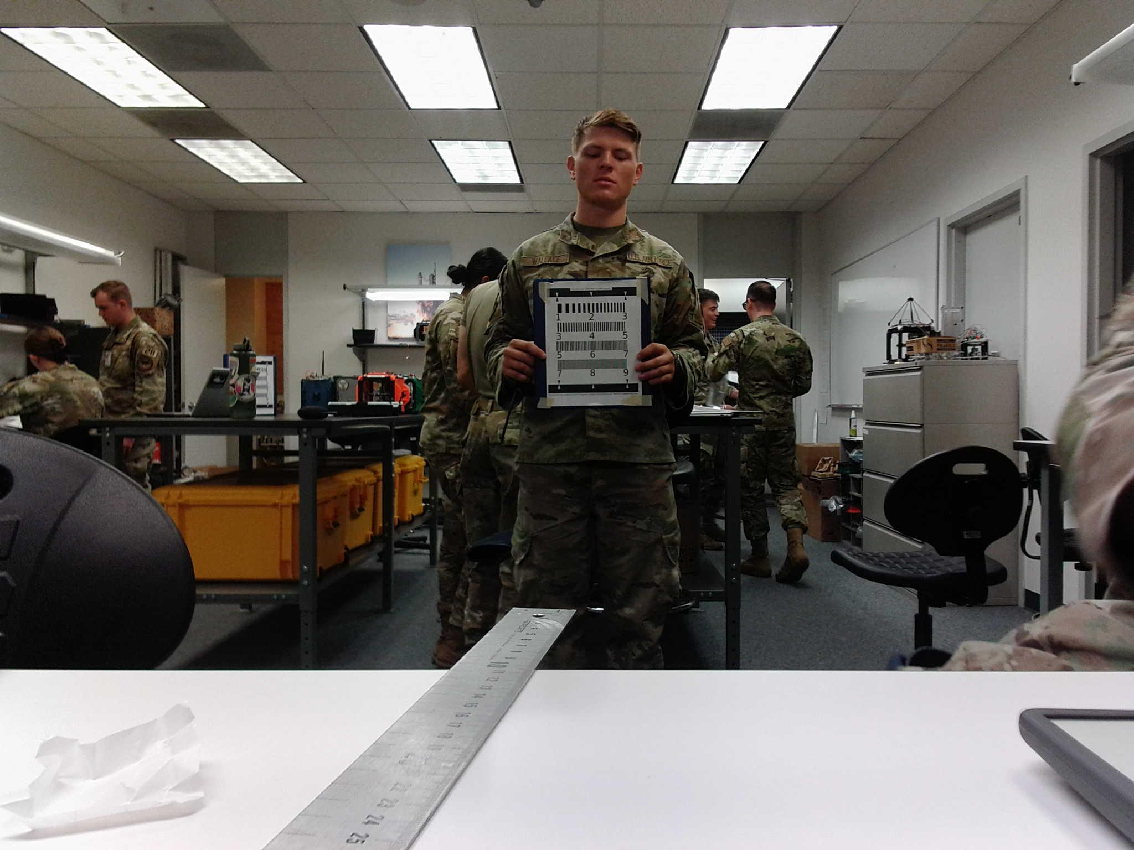
Figure 4: 2m distance, Side 2

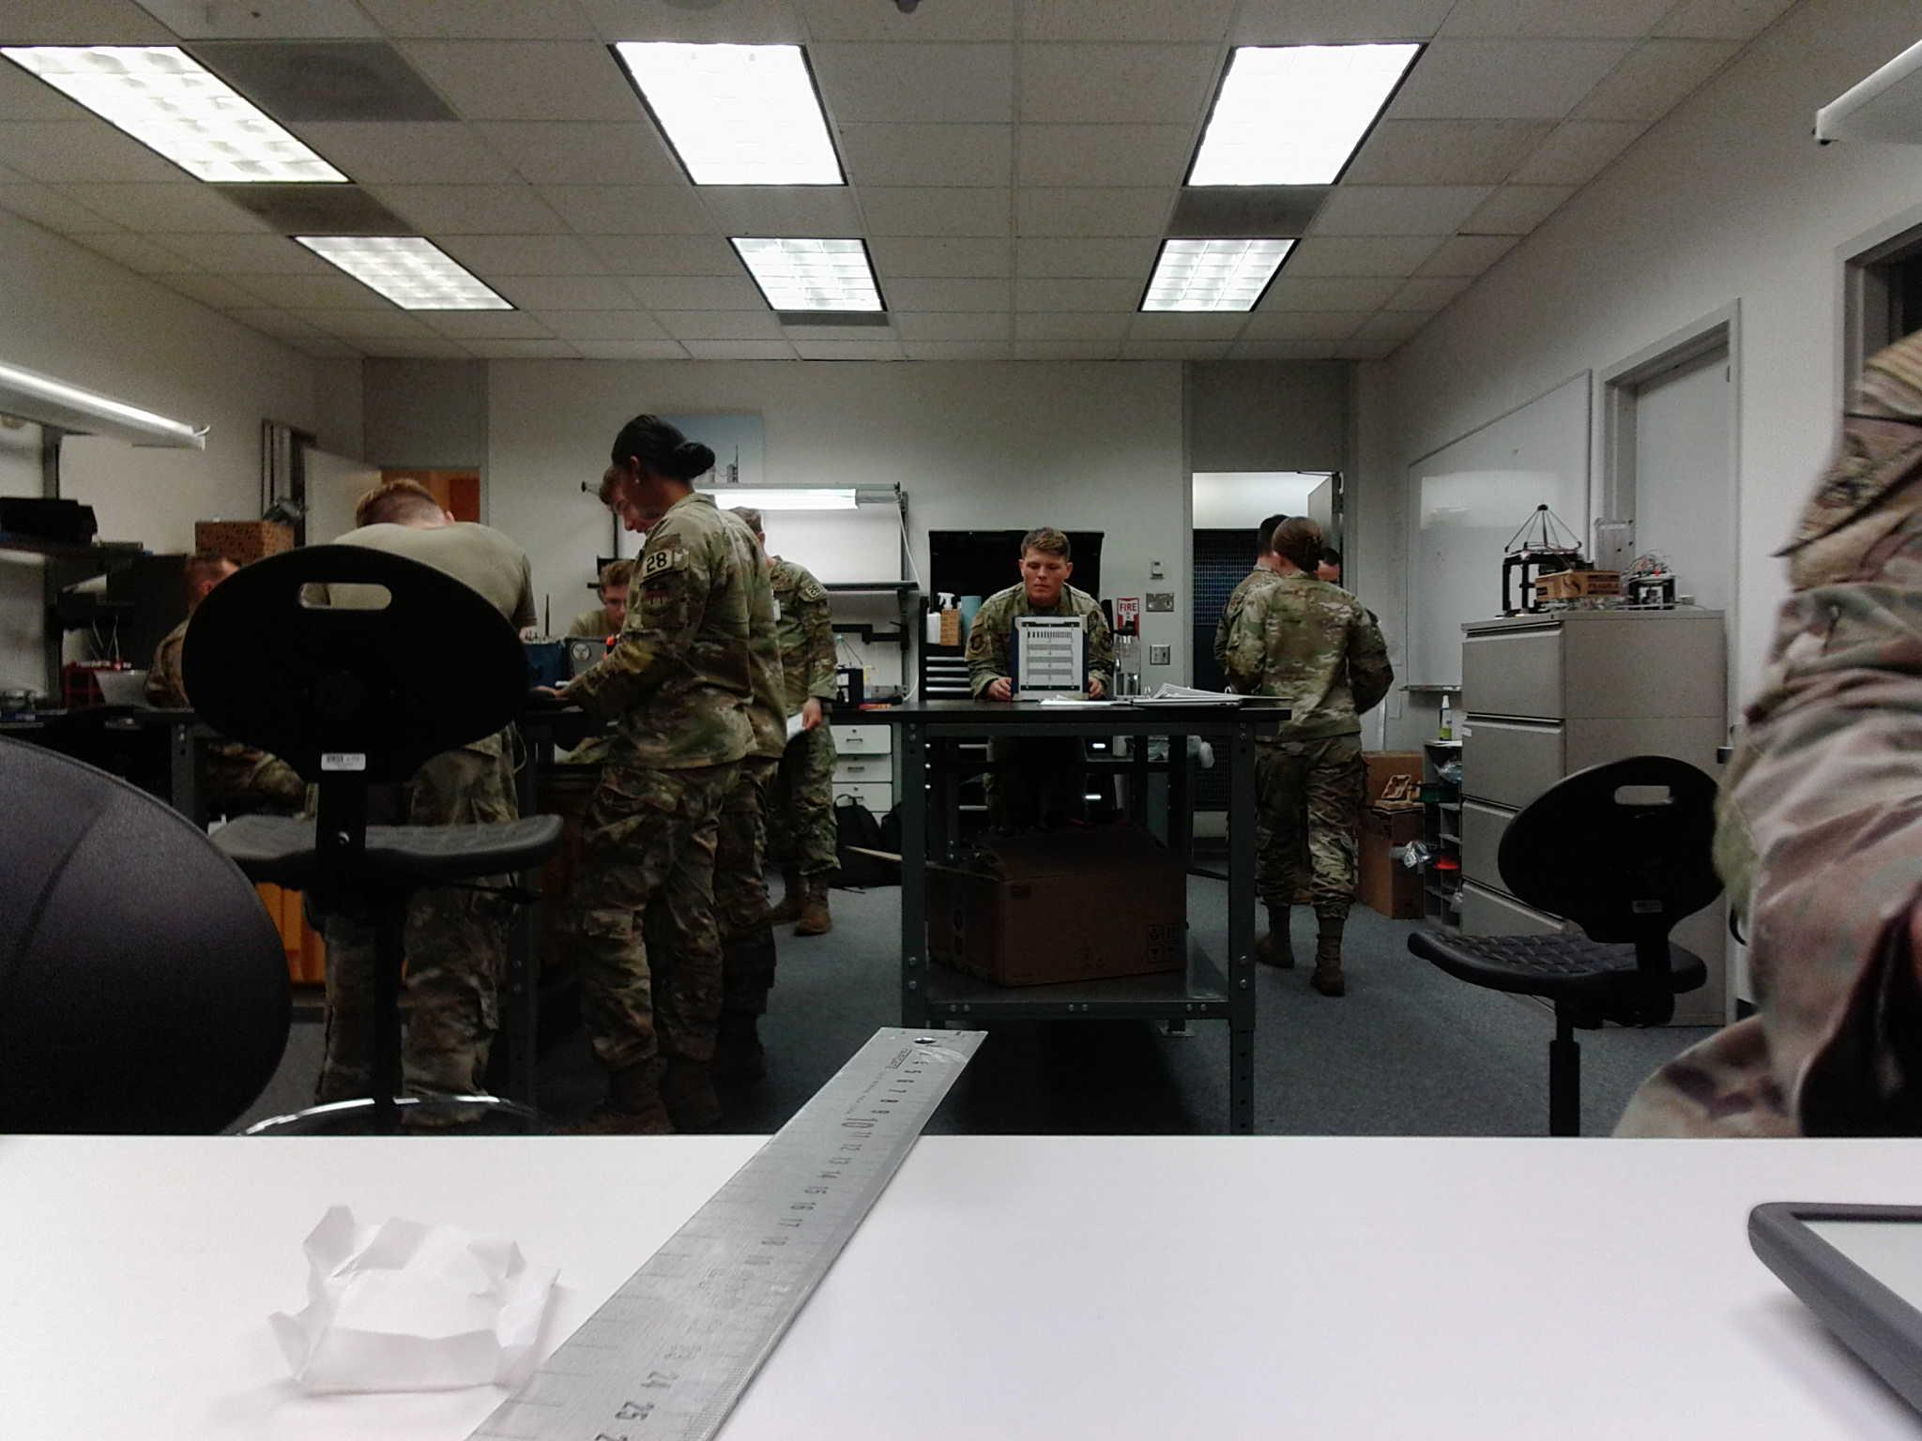
Figure 5: 5m distance, Side 2

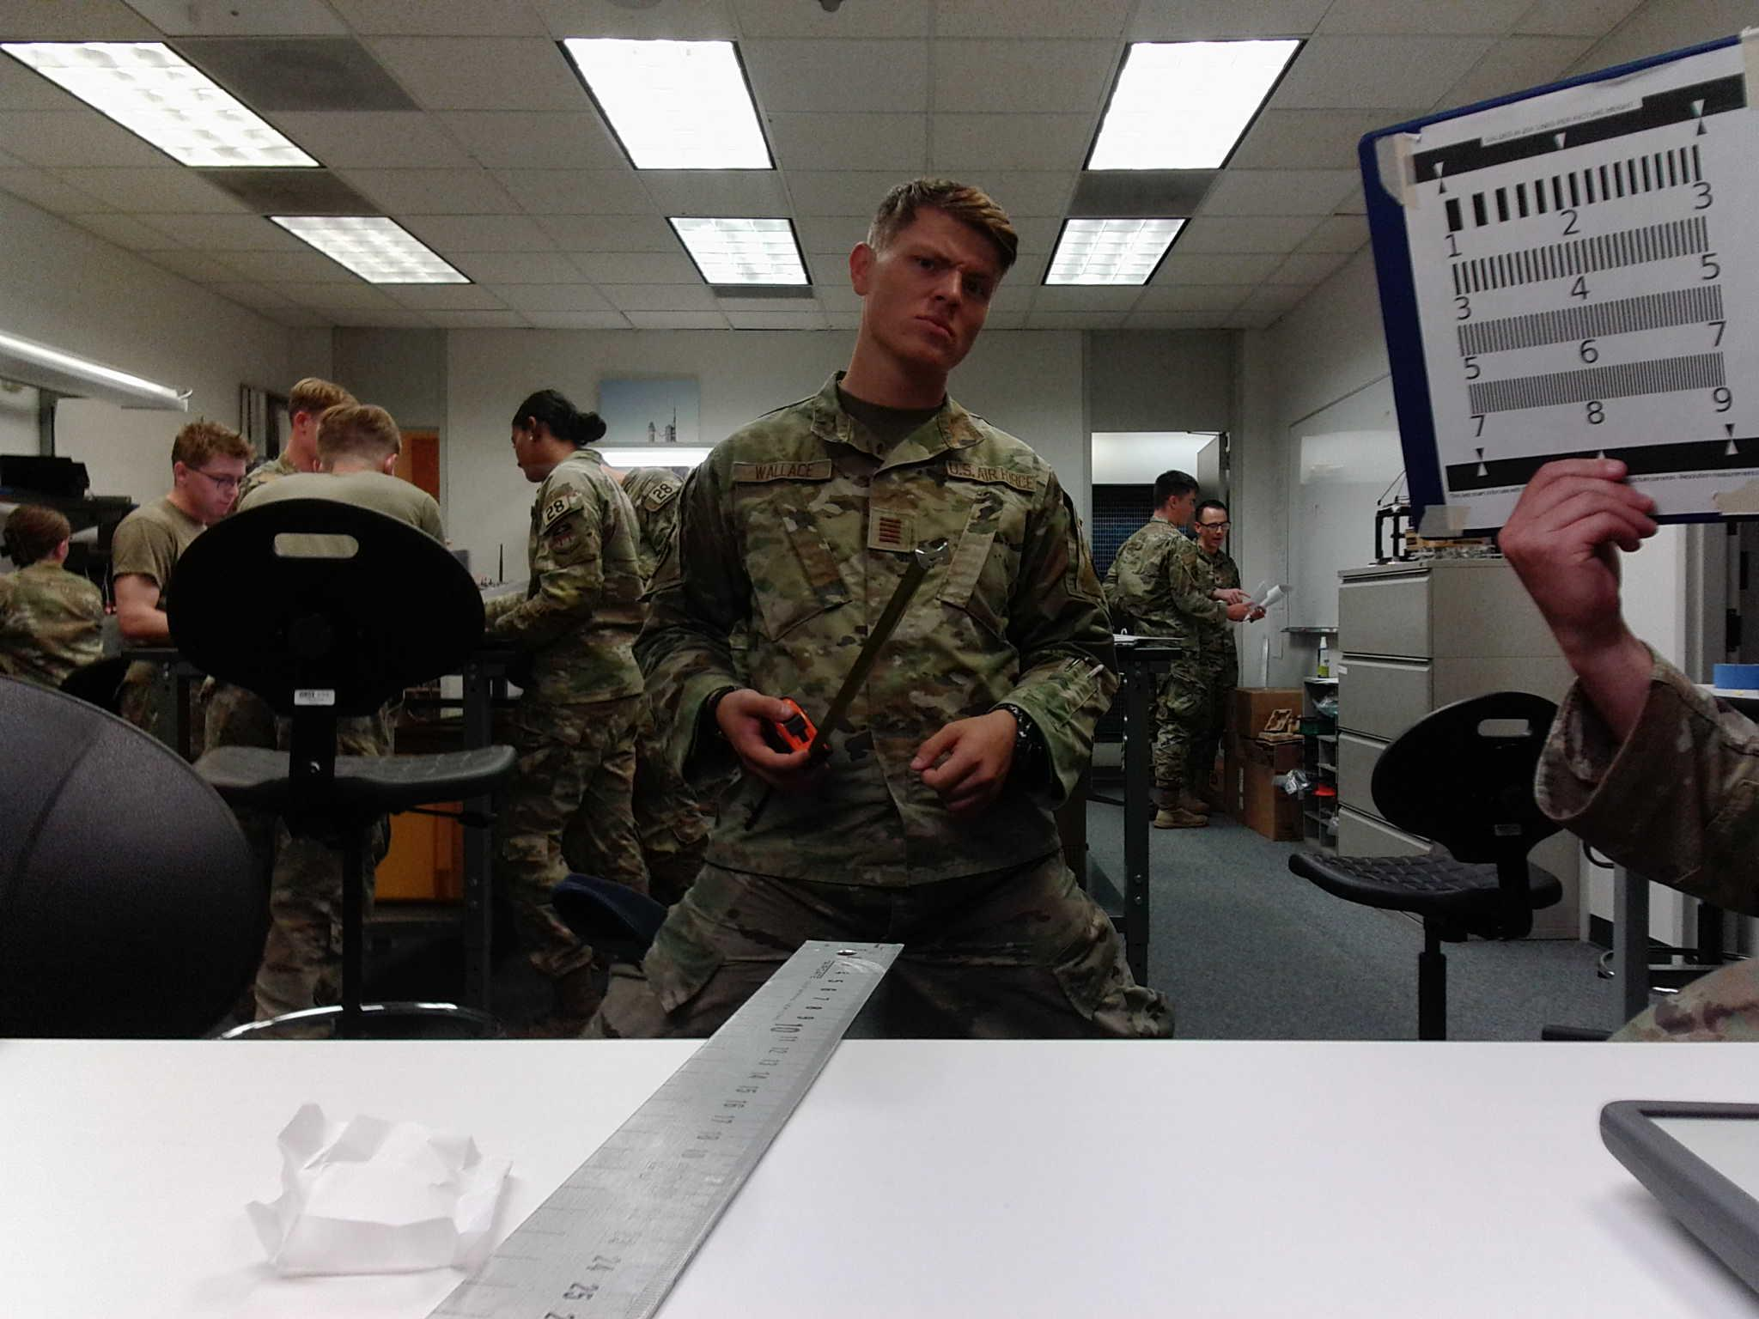
Figure 6: Top right corner distortion, Side 1
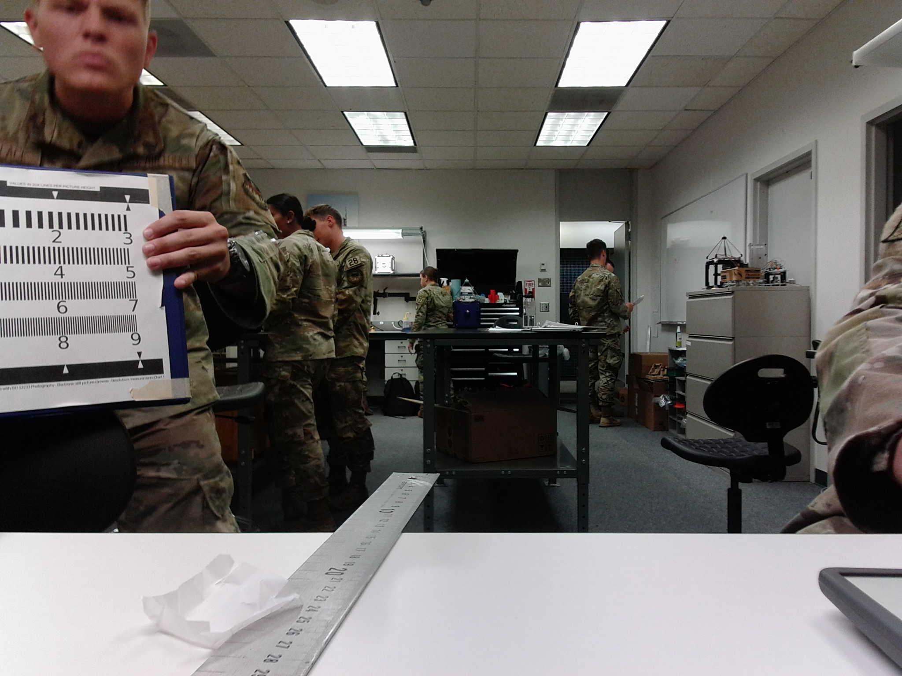
Figure 7: Right (bottom) corner distortion, Side 1

